DATA FROM [OASIS API](http://www.caiso.com/Documents/OASIS-InterfaceSpecification_v5_0_0Redline_Fall2017Release.pdf)

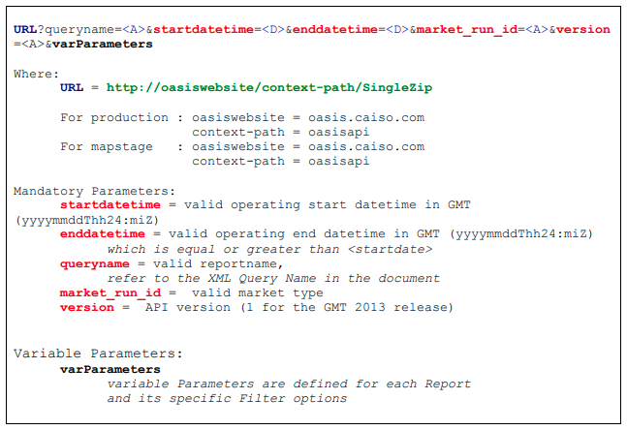

**DA LMP:** Hourly Locational Marginal Prices for all PNodes and APNodes in $/MWh. For the DAM, posts the LMP, plus the Congestion, Loss and Energy Components that make up the LMP. For the RUC, only the LMP will be posted. Oasis will include separate XML file for each price component within the same zip file. This is existing functionality.

<http://oasis.caiso.com/oasisapi/SingleZip?queryname=PRC_LMP&startdatetime=20201201T07:00-0000&enddatetime=20201231T07:00-0000&resultformat=6&market_run_id=DAM&version=1&node=TH_SP15_GEN-APND>,TH_NP15_GEN-APND ,TH_ZP26_GEN-APND

**data before 2017/09/01 wasn’t available

**RT LMP:** Five-minute Locational Marginal Prices for all PNodes and all APNodes in $/MWh, for each five-minute interval RTM. Posts the LMP, plus the Congestion, Loss and Energy Components that makes up the LMP. Node on the report will include Pnodes and APnodes in ISO, EIM and non-EIM external networks Oasis will include separate XML file for each price component within the same zip file. This is current behavior for DAM. This behavior will be extended for other realtime markets in version 3.

<http://oasis.caiso.com/oasisapi/SingleZip?queryname=PRC_INTVL_LMP&startdatetime=20180101T07:00-0000&enddatetime=20180131T07:00-0000&resultformat=6&market_run_id=RTM&version=1&node=TH_SP15_GEN-APND>,TH_NP15_GEN-APND,TH_ZP26_GEN-APND

* Node names (edit for DA and RT):
  + TH_SP15_GEN-APND
  + TH_NP15_GEN-APND
  + TH_ZP26_GEN-APND

**DEMAND FORECAST (ACTUAL):** Daily posting for the 2-DA,7-DA hourly forecast, DAM hourly forecast by TAC area. Hourly posting for the hourly Actual Demand by TAC area. 15-minute posting for the RTPD markets by TAC area. RTM 5-Minute Load Forecast is posted every five minutes, for the next 11 intervals. The postings occur every 5-minutes for a rolling 11 interval period.

<http://oasis.caiso.com/oasisapi/SingleZip?queryname=SLD_FCST&market_run_id=ACTUAL&startdatetime=20201101T07:00-0000&enddatetime=20201130T07:00-0000&resultformat=6&version=1>

**SOLAR AND WIND FORECAST (ACTUAL):** Forecast and actual wind and solar generation by hour. Aggregated by trading hub (NP15, ZP26, and SP15). Day-Ahead forecast is posted daily in advance of the Day-Ahead Market, Hour-Ahead forecast is posted in advance of each HASP market. RTPD forecast is posted in advance of each RTPD market run by 15-minute intervals. RTD forecast is posted in advance of each RTD run by 5-minute intervals. Actual production is posted the day after the operating day. Note: to ensure a high level of accuracy only Eligible Intermittent Resources (EIR), including those that participate in the Participating Intermittent Resource program (PIRP) are included in the report

[http://oasis.caiso.com/oasisapi/SingleZip?queryname=SLD_REN_FCST&startdatetime=20201101T07:00-0000&enddatetime=20201130T07:00-0000& market_run_id=ACTUAL &resultformat=6&version=1](http://oasis.caiso.com/oasisapi/SingleZip?queryname=SLD_REN_FCST&startdatetime=20201101T07:00-0000&enddatetime=20201130T07:00-0000&%20market_run_id=ACTUAL%20&resultformat=6&version=1)

**AS RESULTS:** Ancillary Service Capacity procured and self scheduled, by AS type, posted for each AS Region. Also posts the sum of the procured and self-scheduled. Posts Hourly for the Day-Ahead (DAM), HASP. And in 15 Minute (RTPD) intervals, by AS type. Also posts Total AS Cost for each AS Region, by AS Type.

<http://oasis.caiso.com/oasisapi/SingleZip?queryname=AS_RESULTS&market_run_id=RTM&anc_type=ALL&anc_region=AS_CAISO&startdatetime=20201101T07:00-0000&enddatetime=20201130T07:00-0000&resultformat=6&version=1>

* Different result types to filter during EDA:
  + AS_BUY_MW
  + AS_SELF_MW
  + **AS_COST (Use)**
  + **AS_MW (Use)**
* Different regions to filter during EDA:
  + AS_SP26
  + **AS_CAISO (Use)**
  + AS_SP26_EXP

**DA AS CLEARING PRICES:**

<http://oasis.caiso.com/oasisapi/GroupZip?groupid=DAM_PRC_AS_GRP&startdatetime=20130919T07:00-0000&resultformat=6&version=1>

**RT AS CLEARING PRICES:**

<http://oasis.caiso.com/oasisapi/GroupZip?groupid=RTM_PRC_AS_GRP&startdatetime=20130919T07:00-0000&resultformat=6&version=1>

* These might be repetitive if we’re using AS_COST from AS_RESULTS

**HOUR:** Obtain from price data

**MONTH:** Obtain from price data

**PRICE LAGS:** Obtain from price data

DATA FROM OTHER SOURCES

**NATURAL GAS PRICES:** Daily prices or DA estimates from S&P Global Market intelligence. Data for a variety of locations, should choose one within CAISO.

**CEC FORECAST:** PV generation, EV load, load